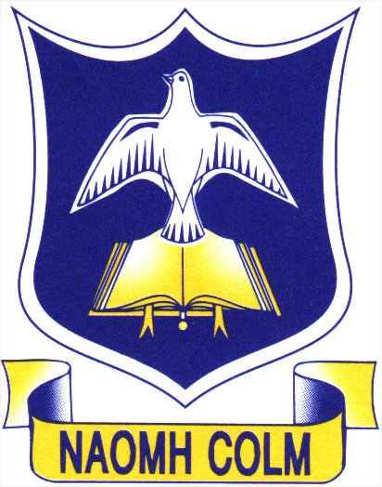
St Colm’s High School
Curriculum Policy

Introduction

Our Mission Statement

St Colm’s seeks to develop a Catholic school community which is well ordered and within which staff and pupils can work co-operatively and in mutual respect in the pursuit of all aspects of spiritual, educational and personal excellence.

In St Colm’s we believe in creating a supportive learning environment by ensuring that the contribution of all pupils is valued and that pupils feel cared and respected.

Key Stage 3 Curriculum & Rationale

- St Colm’s offers the New Northern Ireland Curriculum
- The curriculum is skills-based containing the common theme of learning for life and work
- The curriculum is infused with thinking skills and personal capabilities
- It aims to empower young people to achieve their potential
- It enables our young people to make informed and responsible choices
- The curriculum is broad, balanced and challenging with an emphasis on raising standards of achievement
- We believe we are preparing our young people as life long learners
- In keeping with the priorities enshrined in our School Development Plan we seek to:

  - Continue to foster high self-esteem and expectations
  - Improving pupils’ attendance, punctuality and behaviour
  - Improving levels of achievement in literacy, numeracy and ICT
  - Increasing the pupils’ range and level of achievements generally

Curriculum Objectives

- To develop the young person as an individual
- To develop the young person as a contributor to society
- To develop the young person as a contributor to the economy and the environment

The subjects taught at Key Stage 3 include:

Art Drama
Music Physical Education
Home Economics Citizenship
Employability Personal Development
English Mathematics
Geography History
Religious Education Irish
French Science
Technology

Key Stage 4

At Key Stage 4 our pupils have access to a broad and balanced curriculum which promotes spiritual, emotional, moral, cultural, intellectual and physical development of pupils. It prepares young people for experiences of life by equipping them with appropriate knowledge, understanding and skills.

St Colm’s provides learning opportunities in relation to the following areas of learning:

Religious Education Modern Foreign Languages
Mathematics Modern Arts
The Arts Environment & Society
Science & Technology Learning for Life and Work
Information & Communication Technology Physical Education

Homework

Homeworks are given on a regular basis and should be recorded in pupil planners. It is marked in accordance with our policy on pointing out the errors. One piece of work per child per month should be marked in-depth. This means the teacher decides which errors he/she is concentrating on in this piece e.g. spelling, punctuation or sentence structure. These errors must be indicated for the pupil according to school policy. All other homeworks should be read, signed and dated.

Formal assignments require closer marking and suggestions for re-drafting. They should reflect the highest standard of content and presentation of which a pupil is capable.

Heads of Department have ultimate responsibility for monitoring, supported by Year Heads and Curriculum Co-ordinators.

Assessment

Assessment is an integral component in the whole process of learning and teaching. The main purposes are listed below:

- To offer feedback to pupils
- To highlight progress made by pupils
- To foster self esteem
- To identify strengths and areas for improvement with a view to enabling strategies to be developed for further improvement
- To improve motivation levels in our pupils and develop confidence and a willingness to take risks
- To enable teachers/departments to set meaningful targets
- To aid in effective reporting to parents
- To provide information to teachers, learners and parents about ability/skills development in our pupils
- To provide an aid to standardisation within departments
- To meet statutory requirements

To achieve the above, teachers must ensure assessment:

- Is fully integrated into the learning and teaching process
- Is frequent, structured, relevant and rigorous
- Is positive, supportive, constructive and informative
- Encourages pupils to become reflective learners
- Encourages progression in learning
- Has the full understanding of our pupils
- Is clearly focused and understood by pupils and teachers
- Is monitored regularly
- Encourages parental involvement

Assessment in departments is likely to involve a combination of the methods listed below:

- Formative assessment
- Summative assessment
- Oral assessment
- Written assessment
- Peer assessment
- Self assessment

Examination Entry

St Colm’s has a 100% entry policy for students at level 2/GCSE standard.

